2011
Genetically Modified Organisms

Jayme Lynn Prokes
Genetically Modified Organisms

CONTENTS

PAGE 1: BACKGROUND
PAGE 2: ABOUT GMO’s
PAGE 3: USES OF GMO’s
PAGE 4: BENEFITS OF GMO’s
PAGE 5: WORKS CITED

BACKGROUND

WHEN DID IT BEGIN?
Genetic Modification began in 1972. It began by creating an E. Coli bacteria with a salmonella gene.

HOW IS IT DONE?
Genetic modification can be done a few different ways; one way to modify an organism is to insert extra DNA into the nucleus with a very small needle. Another way is to insert the very small particles with a gene gun.

EXPANSION OF GMO’S
In 1994, Genetically Engineered foods were introduced into the markets in the United States. By 1996 Genetically modified crops were introduced to farmers. In the beginning, there were 4.3 million acres planted in 6 countries, which relatively quickly expanded to 167.2 million acres, as seen in figure 1.1.

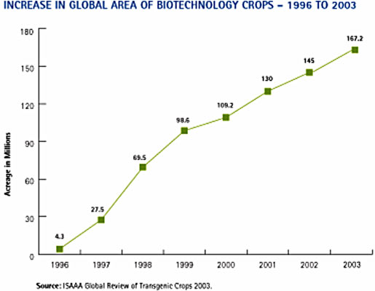
Figure 1.1
The rapid expansion of the use of genetically modified organisms is due to the many different benefits that it produces, as well as the ability to produce and sell a new product to nations that have not yet discovered or began producing the product.

Genetically Modified Organisms (GMO’s) are organisms with altered genetic make-up. These organisms could include bacteria, fungus, plants and animals. The purpose of modifying the genes is to gain a certain benefit, such as more of a certain nutrient, or a resistance to weeds or diseases.

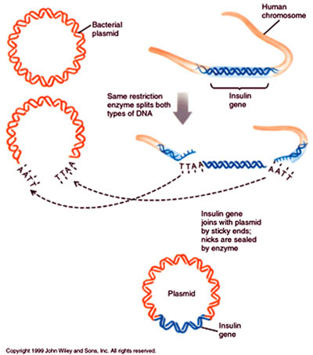
Figure 1.2
Figure 1.2 shows the process of Genetically Modifying an organism. In this diagram shows making a bacterial gene resistant to insulin. They split the DNA in both chains and insert the desired portion of DNA into the old strand to create the desired outcome. Now the old strand of DNA now has a section that makes it resistant to insulin. This is used frequently to make crops that are resistant to certain diseases and parasites.
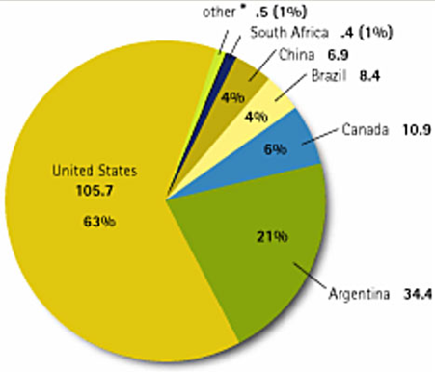
Figure 1.3
Figure 1.3 shows the top 7 countries to produce Genetically Modified Organisms. The numbers represent the number of acres (in millions) that each country uses to produce GMO’s. The percentages represent the percent of the world GMO production in each country. The United States is the leader in the production of GMO’s. The United States is pioneering more productive GMO’s for advancement in society. This does not only benefit the economy of the United States but it will help the United States become a world leader once again.

USES
There are multiple different uses for Genetically Modified Organisms, ranging from resistance, rapid growth, vitamin enhancement, and many others.
- In dairy cows GMO’s are used to increase milk production, as well as increase desired components in milk such as milk fat used in butter.

- In beef cattle GMO’s are in the form of an implant to make the cattle gain weight rapidly so the production of cattle is cost efficient.

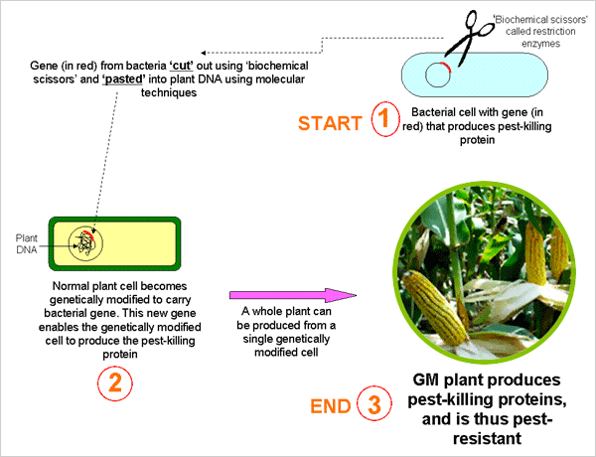
- In corn GMO’s are used to create a resistance against weeds and parasites that can decrease the yield of the crop that year.

- In bacteria GMO’s are used to create vaccines and pharmaceutical products, such as genetically modified insulin and different vitamins.

- Soybeans are genetically modified to increase the amounts of isoflavones, which are substances that have the following health benefits for humans:
- Lower cholesterol.
- Prevent cancers.
- Benefits for women during menopause.

- In humans they have used genetically modified organisms to study unknown disease to try to create a vaccine.

BENEFITS
The reason for the great expansion of the use of genetically modified animals is the many economic and other benefits of using the new product. The benefits include:
- Selling the new product to foreign nations that have not yet engineered Genetically Modified Organisms which raises the nations GDP.

- Using the new genetically modified organisms to grow more of a product at a more cost efficient price. The less price of a product the more that will be produced, therefore causing an increase in products on the market.

- The higher the yield a farmer gets a year at a lower initial seed cost, the likelier they are to sell on a down market therefore lowering the prices of those crops.

- When using GMO’s in beef cattle, the cows are more likely to put on weight in a cost efficient time period.

- With all the cost efficient practices for farmers, their extra profits can lead to a jumpstart of the economy, with them buying more equipment and products.

- Also along with the farmer’s profits, it will trickle down to the consumers. With the profit for farmer and the rising chance they will sell on a down market, the costs of products are likely to decrease therefore giving a cost break to a consumer buying the products.

WORKS RESOURCED

Alred, Gerald J., Charles T. Brusaw, and Walter E. Oliu. "Newsletters." Handbook of Technical Writing. Boston: Bedford/St. Martins, 2009. 341-45. Print.
Johnson-Sheehan, Richard. "Chapter 6." Technical Communication Today. New York: Longman, 2010. 119-38. Print.

WORKS CITED

"Environmental Impacts of Genetically Modified Organisms." Kanat's Home Page. Web. 07 Mar. 2011. <http://kanat.jsc.vsc.edu/student/gilbert/content.htm>.
Keim, Brandon. "The First Genetically Modified Human Embryo: Advance or Abomination? | Wired Science | Wired.com." Wired.com. Web. 07 Mar. 2011. <http://www.wired.com/wiredscience/2008/05/the-first-genet/>.

Llaguno, Claro. "Genetically Modified Organisms." Institute of Chemistry, College of Science.

Millis N 2006, ‘Genetically modified organisms’ paper prepared for the 2006 Australian State
of the Environment Committee, Department of the Environment and Heritage, Canberra,
<http://www.deh.gov.au/soe/2006/emerging/gmo/index.html>.

Singer, Maxine F. "Genetically Modified Organisms." Engineering and environmental Challenges. Print

